PIZZA SALES ANALYSIS SQL QUERIES

**A) KPIs:**

**1. Total Revenue:**

select sum(total_price) as Total_Revenue from pizza_sales;

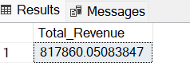

**2. Average Order Value:**

select sum(total_price)/count(distinct(order_id)) as Average_Order_value

from pizza_sales;

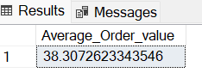

**3. Total Pizza Sold:**

select sum(quantity) as Total_Pizzas from pizza_sales;

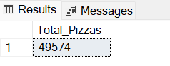

**4. Total Orders:**

select count(distinct(order_id)) as Total_Orders from pizza_sales;

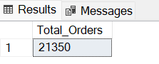

**5. Average Pizzas Per Order:**

select cast(count(pizza_id) as decimal (10,2)) / cast(count(distinct(order_id)) as decimal (10,2)) as Avg_Pizzas_Per_Order

from pizza_sales;

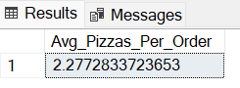

**B) Daily Trend for Total Orders:**

select datename(DW, order_date) as week_days, count(distinct(order_id)) as Total_orders

from pizza_sales

group by datename(DW, order_date);

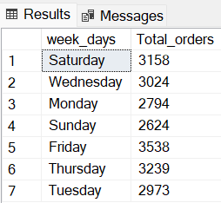

**C) Monthly Trend for Total Orders:**

select datename(month, order_date) as Months, count(distinct(order_id)) as Total_orders

from pizza_sales

group by datename(month, order_date);

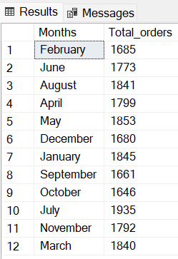

**D) PCT (%) of Sales by Pizza Category:**

select pizza_category, cast(sum(total_price) as decimal(10,2)) as Total_Revenue,

cast(sum(total_price)*100/(select sum(total_price) from pizza_sales) as decimal(10,2)) as PCT

from pizza_sales

group by pizza_category

order by PCT desc;

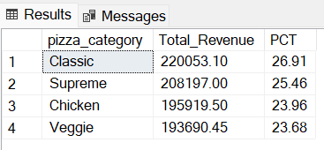

**E) PCT (%) of Sales by Pizza Size:**

select pizza_size, cast(sum(total_price) as decimal(10,2)) as Total_Revenue,

cast(sum(total_price)*100/(select sum(total_price) from pizza_sales) as decimal(10,2)) as PCT

from pizza_sales

group by pizza_size

order by PCT desc;

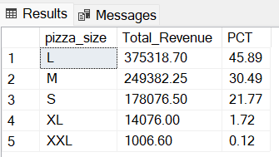

**F) Total Pizza Sold by Pizza Category:**

select pizza_category, sum(quantity) as Total_Pizza_by_Category

from pizza_sales

group by pizza_category

order by sum(quantity) desc;

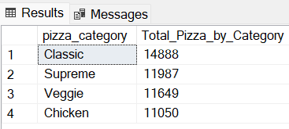

**G) Top 5 Pizzas by Revenue:**

select top 5 pizza_name, cast(sum(total_price) as decimal(10,2))

as Revenue

from pizza_sales

group by pizza_name

order by Revenue desc;

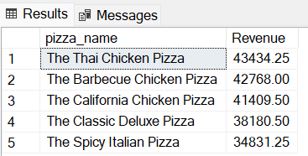

**H) Bottom 5 Pizzas by Revenue:**

select top 5 pizza_name, cast(sum(total_price) as decimal(10,2))

as Revenue

from pizza_sales

group by pizza_name

order by Revenue;

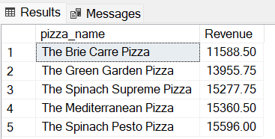

**I) Top 5 Pizzas by Quantity:**

select top 5 pizza_name, sum(quantity) as Quantity_Sold

from pizza_sales

group by pizza_name

order by sum(quantity) desc;

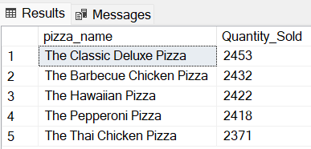

**J) Bottom 5 Pizzas by Quantity:**

select top 5 pizza_name, sum(quantity) as Quantity_Sold

from pizza_sales

group by pizza_name

order by sum(quantity);

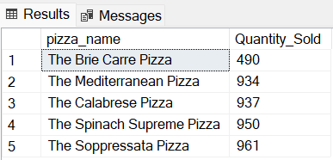

**K) Top 5 Pizzas by Total Orders:**

select top 5 pizza_name, count(distinct(order_id)) as Total_Orders

from pizza_sales

group by pizza_name

order by Total_Orders desc;

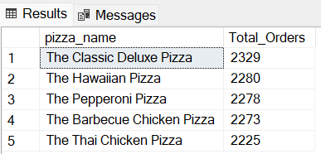

**L) Bottom 5 Pizzas by Total Orders:**

select top 5 pizza_name, count(distinct(order_id)) as Total_Orders

from pizza_sales

group by pizza_name

order by Total_Orders;

